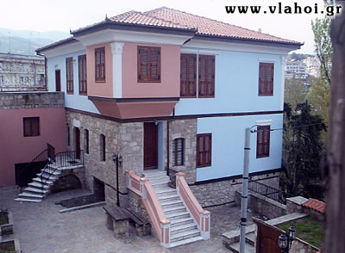
PROTOCOL NUMBER:55
VERIA 14/05/2013
To the President of the ROMANIAN PARLIAMENT
Bucuresti –Romania
To our great astonishment we have been informed that on the session of your Parliament that took place on the 8th of May 2013 you brought on the surface the issue of the law 299/2007 of your country with slight but significant changes.
The Parliament of Romania adopted a Draft Law to transform the article 1, of the paragraph 1 of the Law 299/2007. This specific Law, with these outrageous additions that are proposed to valid, states that “ all people Vlachs-Armanji-Mogletoarmanji-Remenji” including those who live in the South Balkan Peninsula ARE ROMANIAN CITIZENS no matter if they live in another country or how they introduce and identify themselves.
We are absolutely surprised negatively, for this action of the members of the Romanian Parliament, a country with a European orientation and full member of the European Union, they violate blatantly the European vested rights that concern the right of every individual to “Identify himself”.
We really wonder, who authorized the Deputies of the Romanian Parliament to speak for ourselves (the Vlachs-Armanji-Remenji…) and decide for us or on behalf of us (the Vlachs-Armanji-Remenji…)?
Nobody has the right and CANNOT distort unacceptably the Historical Truth and impose or declare on us (the Vlachs-Armanji-Remenji…) WHO WE SHOULD BE!
The Association of Vlachs of Veria (Sutsata Armanjilor di Veria) on behalf of the members and friends of our assotiation,( representing their point of view) we are all Greeks, Vlach descendants and Vlach (Armanji) origin, we declare once again clearly into every direction and we want to make it clear once again (and hope to be the last) that:
- We have never been Romanians, we are not Romanians and we will never be Romanians.
- We unequivocally condemn every action that is trying to “Identify ourselves” (the Vlachs-Armanji) one way or another.
- We will not allow and permit anyone to play any diplomatic or political games on our backs, as it happened during the end of the 19th century and the beginning of the 20th century with devastating and tragic consequences against the Vlachs-Armanji. Those eras have irrevocably gone away.

The President  Dimitrios Piskos | The General Secretary  Antonios Tousikos

